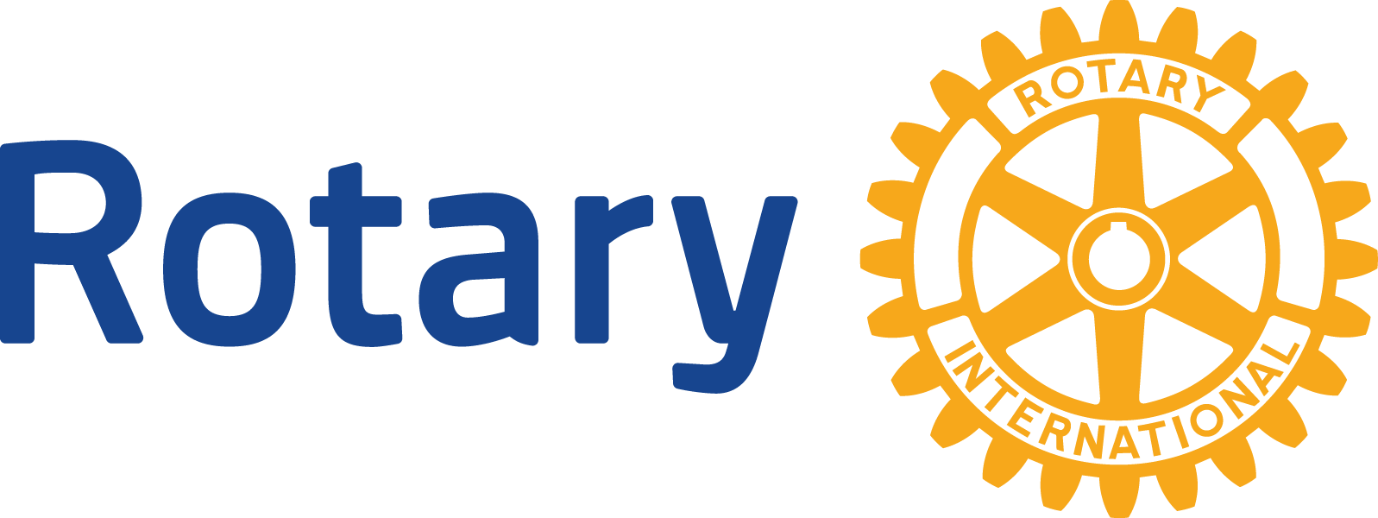

ENGLISH (EN)

# Eradicating polio

the need

Although it currently circulates in only a few countries, polio is highly infectious and spreads rapidly. The disease, which afflicts mainly children, is transmitted via contaminated water and food supplies. Five percent to 10 percent of cases are fatal.

As long as polio threatens even one child anywhere in the world, children everywhere are at risk. Only the global eradication of polio will ensure that no child ever again suffers its devastating effects.

Where we are today

Since Rotary launched PolioPlus in 1985:

• Polio has decreased by 99.9 percent.

• Rotary and its partners have reduced the number of polio cases from 350,000 in 1985 to fewer than 50 in September 2015.

• In September, the World Health Organization (WHO) removed Nigeria, once polio’s gateway to Africa, from the list of polio-endemic countries. And all of Africa is close to becoming polio-free.

• The number of polio-endemic countries (those where the transmission of the wild poliovirus has never been stopped) has decreased from 125 to two: Pakistan and Afghanistan. Pakistan reduced its number of cases by 75 percent in 2015.

• Wild poliovirus type 2 was [certified as eradicated](http://www.polioeradication.org/mediaroom/newsstories/Global-eradication-of-wild-poliovirus-type-2-declared/tabid/526/news/1289/Default.aspx) in September 2015

Rotary’s role

Rotary had the vision “to immunize all of the world’s children against polio,” which began with the creation of PolioPlus in 1985. The goal expanded to eradicating the disease in 1988, when the World Health Assembly (the governing body of the World Health Organization) resolved to end polio. Toward that goal, Rotary helped assemble the partnerships with WHO, UNICEF, and the U.S. Centers for Disease Control and Prevention that established the [Global Polio Eradication Initiative](http://www.polioeradication.org) (GPEI).

Rotary is a leading partner in the GPEI, which also includes the Bill & Melinda Gates Foundation. Rotarians raise funds, secure support from governments, nongovernmental organizations, corporations, and the public; immunize children, and promote awareness in their communities.

Rotary has helped immunize more than 2.5 billion children against polio, contributed over $1.5 billion to the GPEI, and helped secure over $7.2 billion from donor governments.

How we will eradicate polio

The GPEI is working to interrupt transmission of the wild poliovirus through:

• [Routine immunization coverage](http://www.polioeradication.org/Aboutus/Strategy/Routineimmunization.aspx) of more than 80 percent of children in the first year of life. This requires at least three doses of the oral polio vaccine as part of national immunization schedules.

• [Supplementary immunization activities](http://www.polioeradication.org/Aboutus/Strategy/Supplementaryimmunization.aspx), including National Immunization Days, to immunize children under five with two doses of oral polio vaccine.

• [Surveillance](http://www.polioeradication.org/dataandmonitoring/Surveillance.aspx) (identification and prompt reporting) by health workers of every case of acute flaccid paralysis (sudden weakness that may be caused by the poliovirus).

• [Targeted mop-up campaigns](http://www.polioeradication.org/Aboutus/Strategy/Targetedmopupcampagins.aspx) where the poliovirus is known or thought to be present.

Where we are headed

Failure to end polio would mean 200,000 new polio cases annually. The GPEI’s [Polio Eradication and Endgame Strategic Plan 2013-2018](http://www.polioeradication.org/resourcelibrary/strategyandwork.aspx) is aimed at the rapid, simultaneous eradication of all polioviruses (wild and vaccine-derived), paving the way for [global certification](http://www.polioeradication.org/Portals/0/Document/Aboutus/Governance/POB/POB_Statement_20150925.pdf) in 2019.

As long as the wild poliovirus circulates in Pakistan and Afghanistan, the risk of the disease’s global spread remains high. However, outbreaks can be rapidly stopped, as seen in ongoing response activities across the Horn of Africa and the Middle East in 2014.

How Rotary’s contributions are spent

Through PolioPlus, Rotary initially paid for oral polio vaccine and start-up costs for Rotarians’ social mobilization efforts in endemic countries. Rotary now funds operational needs, technical advisers’ salaries, surveillance, social mobilization, stipends for millions of volunteers who conduct National Immunization Days and house-to-house follow-up visits, and research on ways to facilitate eradication.

What polio eradication will cost

The GPEI funding gap for implementing the [polio endgame plan](http://www.polioeradication.org/resourcelibrary/strategyandwork.aspx) is currently about $1.5 billion.

How you can help

Rotary is committed to raising $35 million per year through 2018 as part of the [End Polio Now: Make History Today](http://www.endpolio.org/docs/default-source/take-action/end-polio-now-brochure.pdf?sfvrsn=2) campaign. Every $1 Rotary commits to polio immunization will be matched 2-to-1 (up to $35 million per year) by the Bill & Melinda Gates Foundation. If fully realized, the campaign will result in $525 million for polio eradication. Rotarians can [take action](http://www.endpolio.org/take-action) to hold fundraisers, raise public awareness, write their government representatives, [donate](http://www.endpolio.org/donate), [share stories](http://www.endpolio.org/stories), and encourage others to join our cause.

Rotary’s legacy

Polio eradication, once [certified](http://www.polioeradication.org/Posteradication/Certification.aspx), will generate substantial humanitarian and financial dividends due to the end of polio treatment and rehabilitation costs. A *Vaccine* journal study in 2010 estimates the economic benefits of the GPEI at [$40 billion to $50 billion](http://www.polioeradication.org/Portals/0/Document/Media/News/VaccineStudyFactSheet_20101122.pdf), which could help fund other public health priorities. Rotarians are already supporting some of them as part of PolioPlus, such as immunizing children against measles, distributing vitamin A supplements and bed nets to prevent malaria, and providing clean water. And the polio surveillance network in Nigeria helped the government [stop the Ebola outbreak](https://www.rotary.org/myrotary/en/member-news/rotarys-response-ebola-outbreak) in 2014.

Find out more

Learn more about our polio eradication efforts at [endpolio.org](http://www.endpolio.org/).

The Secretariat’s key experts on eradicating polio are PolioPlus Director [Carol Pandak](mailto:carol.pandak@rotary.org), PolioPlus Advocacy Specialist [Kris Tsau](mailto:Kris.Tsau@rotary.org), and PolioPlus senior coordinators [Clare Monroe](mailto:clare.monroe@rotary.org) and [Amy Edwards](mailto:amy.edwards@rotary.org). Send questions about communications to PolioPlus Communications Senior Specialist [Michelle Kloempken](mailto:michelle.kloempken@rotary.org).