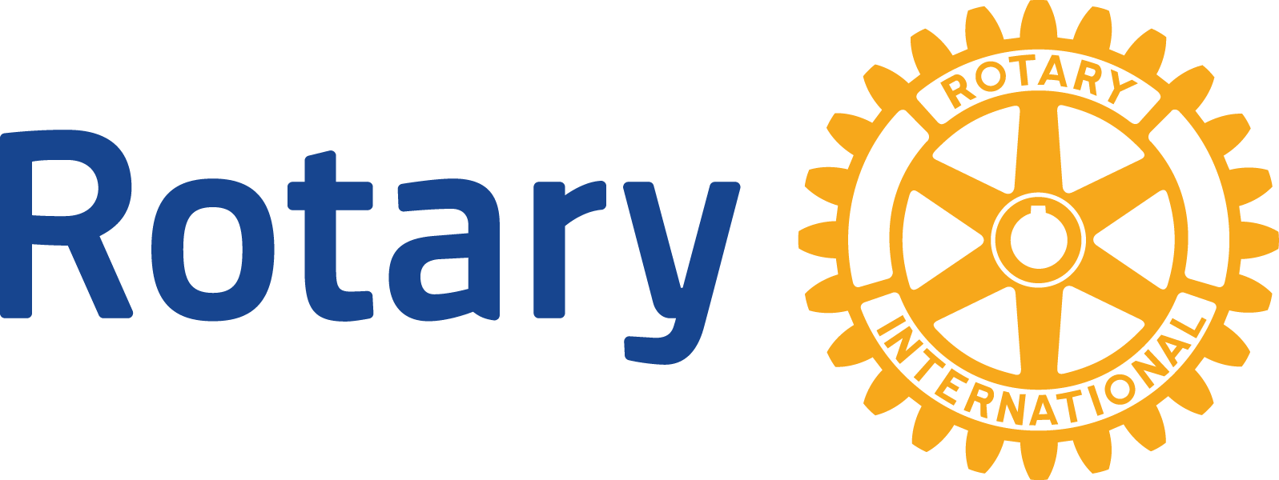
ENGLISH (EN)

Membership Development
We are a membership organization of more than 1.2 million neighbors, friends, and community leaders who join together to share ideas and take action to bring positive, lasting change at home and around the world. Research tells us the reasons people join Rotary and stay in Rotary are the same: to give back to their communities and to make friends.
Who WE are
Rotarians: 1,209,491*
Rotary clubs: 35,114
Rotary districts: 535
Rotaractors (ages 18-30): 187,864
Rotaract clubs: 8,168
Rotary Community Corps: 8,520
*As 1 July 2015
Key membership goals
While polio eradication remains our top priority program, increasing membership is our highest organizational priority.
• We want to grow our membership by 35,000 by 1 July 2016 and increase the number of female Rotarians.
• We want to increase membership retention rates by 1 percent in 2015-16.
Apply best practices
• Resources such as Strengthening Your Membership: Creating Your Membership Development Plan can help clubs evaluate membership trends, create strategies for attracting new members, and develop programs that focus on member engagement.
• Many Rotarians have benefited from the Membership Matters! webinar series, which offers key steps clubs should consider to grow their membership.
• The Membership Best Practices discussion group on Rotary.org provides a forum for leaders at all levels.
• Membership development recommendations drawn from research, pilot programs, and surveys are being incorporated into training materials for district governors.
Catalysts to membership growth
• Our member benefit program — Rotary Global Rewards — can help us attract new members and keep existing ones. The program offers Rotarians discounts on a range of products and services including airfares, car rentals, hotels, dining, entertainment, and merchandise. Club members can use Rotary Global Rewards to accomplish more good work and build deeper Rotary friendships.
• Our regional membership plans can help increase and retain membership worldwide, and support the first priority in our strategic plan: support and strengthen clubs.
• Service, social activities, and professional development opportunities can build effective, lasting relationships with young professionals and the family of Rotary, including Rotaractors, members of Rotary Community Corps, grant recipients, and other program alumni.
• As a result of the Alumni Database Migration project, we now have access to almost 300,000 Rotary alumni, who can be ideal candidates for membership.
Use Rotary membership to make a difference
Rotarians can use their membership to strengthen their club and make a positive impact at home and around the globe in support of our second strategic priority: focus and increase humanitarian service.
• Identify a community need and work with your club to design and carry out a hands-on project that addresses it.
• Use Rotary Global Rewards to accomplish more good work, build deeper Rotary friendships, and reach potential Rotary members.
• Help your club apply for a Rotary grant to support a project.
• Join a Rotarian Action Group to assist clubs and districts with service projects through your skills, expertise, and interests.
• Volunteer to become a club leader where needed.
tools to strengthen your club
• Use Rotary Club Central to help set and track annual goals for club membership, along with service and Foundation giving.
• Use the Rotary Brand Center to display our visual identity and voice in club and district websites, newsletters, and other Rotary communications vehicles. This is an effective way to support our third strategic priority: enhance public image and awareness.
• Include membership development as a key focus of your club’s and district’s strategic plan.
• Use Rotary resources to enhance club service activities.
Find out more
Visit the Member Center and read Global Outlook.
The Secretariat’s key experts on membership development are Chief Programs and Member Services Officer Jim Barnes and Membership Development Director Brian King.
Send questions to rotarysupportcenter@rotary.org.

